# Profile of Shein: A world-renowned unicorn company

### Background

Shein was founded by Chris Xu in Nanjing, China in 2008, and its headquarters relocated to Singapore in 2019. This location enables the company to better manage its global operations and logistics, while also having a strategic position in Southeast Asia. Shein is engaged in the fast fashion industry, characterized by the rapid production of affordable clothing that reflects the latest trends. The company mainly provides various products through its online platform, including clothing, accessories, and home furnishings【1】.

### Mission & Vision

Shein’s mission is to make the beauty of fashion accessible to all, reimagining fashion by leveraging our small-batch on-demand production model. This innovative, customer-driven model allows for more choice at more affordable prices while minimizing waste, by measuring customer preferences more accurately and efficiently.

Their vision is to offer every customer exactly what they want. It’s a vision we’ve worked toward since 2012 by empowering customers, creators, independent suppliers and individual entrepreneurs【2】.

### Accomplishment

Shein has expanded its market in over 150 countries and regions worldwide, and after a round of financing in April 2022, its market value has reached $100 billion. As of 2021, its online platform has reached 7 million monthly active users. In 2022, Shein appeared on Hurun's "Global Unicorn List 2022", worth 400 billion yuan, ranking fifth. In 2023, Shein appeared on Hurun's "2023 Global Unicorn List", worth 450 billion yuan, ranking fourth【3】.

### Business Strategy

Shein’s business strategy is On-Demand Business Model. This is a model that offers more choices, more affordable prices, and less waste. Unlike traditional supply driven models, on-demand models more accurately and effectively meet customer preferences.

Shein's unique digital supply chain enables them to address the mismatch between customer demand and product supply. It needs to test new products by launching them in small batches of 100 to 200 pieces, evaluate customer feedback in real time, and restock products in demand. This highly automated process ensures the ability to minimize overproduction while meeting customer needs. This means that our customers can get more affordable prices and reduce waste.

### Major Countries

Shein has expanded its market in over 150 countries and regions worldwide, with the United States, the United Kingdom, and Brazil being selected for analysis using the HOFSTEDE theory【4】.

The UK has the characteristic of low uncertainty avoidance and maintains a more relaxed attitude towards the emergence of new things. British culture is characterized by a confident orientation, where confidence and independence are highly valued, and individualism and self actualization are seen as important indicators of success. The power distance in British society is relatively small, emphasizing equality and respect for individual rights. This is reflected in the clear boundaries between superiors and subordinates in the workplace and daily life, but overall, more emphasis is placed on individual abilities and contributions.

The United States also has the characteristic of low uncertainty avoidance and maintains a tolerant attitude towards emerging fashion cultures from abroad. American culture emphasizes individualism and self actualization, encouraging individual goals and achievements. In the United States, power distance is relatively small, emphasizing the legitimacy and expert power of power rather than coercive and directive power.

Brazil has the characteristic of high uncertainty avoidance and relies more on social rule management【5】. The power distance in Brazil is relatively high, and class divisions are generally based on wealth and race, with poor people of color often at a disadvantage. Similarly, power and status are crucial for Brazilians to earn respect. The cultural characteristics of Brazil are also characterized by internal collectivism, where Brazilians are placed within large, strong, and cohesive groups.

The United States, the United Kingdom, and Brazil all have the characteristics of indulgence, willingness to satisfy their impulses and desires, and short-term orientation, willing to pay for fast-moving consumer goods,

As a company founded in China, Shein also holds a portion of the market in China. Due to the unique aesthetic characteristics of ethnicity in China compared to other countries, we need to analyze China using the HOFSTEDE theory as well.

According to Hofstede's cultural dimension theory analysis【6】, we can know that Chinese culture has a high power distance index, which can accept unfairness and power differences, accept bureaucracy, and demonstrate a high respect for hierarchy and authority. Faced with orders from superiors, employees are more likely to accept additional workplace requirements such as overtime, and there are also many situations where employees are oppressed by unreasonable orders from their leaders.

Chinese culture tends towards collectivism and masculinization, reflected in the love for competition, pursuit of achievement, and material rewards. The competition in the entire society is more intense, and such a society is more prone to phenomena such as internal competition, one of which is the prevalence of overtime.

### Stakeholders

For the stakeholders, several aspects of stakeholders are involved.

1.Customers: Which is the primary focus of Shein's product offerings.

2. Employees: Integral to the company's operations and innovation.

3.Suppliers: Including manufacturers and designers who contribute to Shein's product range.

4.Investors: Providing capital for expansion and operational growth.

5.Local Communities: Benefiting from Shein’s economic contributions and social initiatives.

### SWOT Analysis

#### Strengths

1. Supplier training: Shein's supplier training initiatives are characterized by comprehensive workshops and ongoing education that ensure compliance with its Supplier Code of Conduct, empowering suppliers to improve their operational standards and uphold ethical practices across the supply chain.

2. Diversity customers and wide global reach: Shein caters to a wide range of demographics, including various age groups, genders, and body types. The brand's inclusive approach has attracted a large customer base. Operating in over 150 markets with a mobile app available in more than 50 languages allows Shein to connect with diverse customers worldwide.

#### Weakness

1. Low awareness: Shein is a relatively new player in the fast fashion industry,having gained prominence only in recent years. The company primarily relies on digital influencer marketing and social media platforms for promotion, which may not reach all demographics effectively.

2. Limited Leadership Diversity: There is insufficient representation of diverse groups in leadership positions, which can impact decision-making processes and the overall workplace culture. This lack of representation can lead to feelings of exclusion among employees from underrepresented background.

#### Opportunity

1. Shein has a strong Internet marketing ability, and the continuous development of the Internet provides Shein with opportunities to expand its influence.

2. Shein has always emphasized its diversity and provided services to different customer groups. The continuous development of feminism and diversity on a global scale has provided Shein with many opportunities.

#### Threats

1. As Shein expands globally, it must comply with various labor laws and regulations in different countries. The changes in these regulations may affect operating costs and procurement practices, making it challenging to maintain consistent DEI standards.

2. The privacy and patent challenges faced by Shein pose a significant threat to its reputation and operational integrity, and Shein has been accused of data breaches in New York State. In India, Shein's app has been banned due to personal privacy concerns【7】【8】.

3. As a company founded in China but primarily targeting the global market rather than the Chinese market, Shein will face serious cultural bias. Some countries have biases due to Shein being a Chinese company, which may distract from actual discussions on corporate accountability. Due to the current tense US China situation, Shein will receive excessive attention in the United States.

# Industry analysis: The unique value of culture and diversity to the fashion industry

### Theory of consumption culture

According to the theory of consumption culture, consumption itself has become a dominant force of culture and therefore has cultural characteristics. Through consumption, consumers not only meet material needs, but also it is a cultural practice. Consumers express their social identity and values through consumption.

### The social constructivism theory

Meanwhile, according to the social constructivism theory, individual cognition is not only influenced by objective things, but also by social symbols, language, culture and so on.

### Stereotype·vulnerability theory

Stereotype susceptibility refers to an individual's fear of being labeled or perceived as conforming to a certain label. Stereotyped anxiety or stress. This feeling can affect a person's performance and self-esteem.

### Analysis of Shein

In terms of design philosophy, Shein meets the needs of different consumers by providing and designing clothing in various styles, sizes and cultural backgrounds. For example, Shein regularly launches clothing collections that reflect different cultures and traditions, such as modest fashion for Muslim consumers, which shows its understanding and respect for multiculturalism.

The designer's values and diversity are reflected in the products.

By responding to such design concepts and buying items with brand culture, consumers show their recognition of designer values and brand values. In this process, consumers' values and cognition are shaped by such cultural practices.

The brand uses such symbols and cultural practices to shape and lead the cognition of consumers and society, and to spread the cultural concept of respecting diversity.

### What Shein should do

Shein brand should be aware of its strong role in shaping social and consumer values as a global brand. It should carefully choose its own development path, carefully select the ideas it conveys, give full play to its leading role in the dissemination of global diversified ideas, and actively spread the right values and guide the right social atmosphere.

At the same time, the management, designers and senior technical workers should be aware of their responsibilities as global citizens. The cultural concepts they transmit will not only affect the group and the country, but also affect the whole world. Moreover, they should carefully select expressions and convey the correct cultural concepts.

The brand also needs to care more about minority group, such as Muslim consumers. Among them, the diversified concept of designers is very important and has a direct impact.

# Current DEI Strategy: dark side behind prosperity

## Diversity Announcement

Shein posted her "Diversity, Equity and Inclusion Statement" on her website, which was last updated in September 2022.

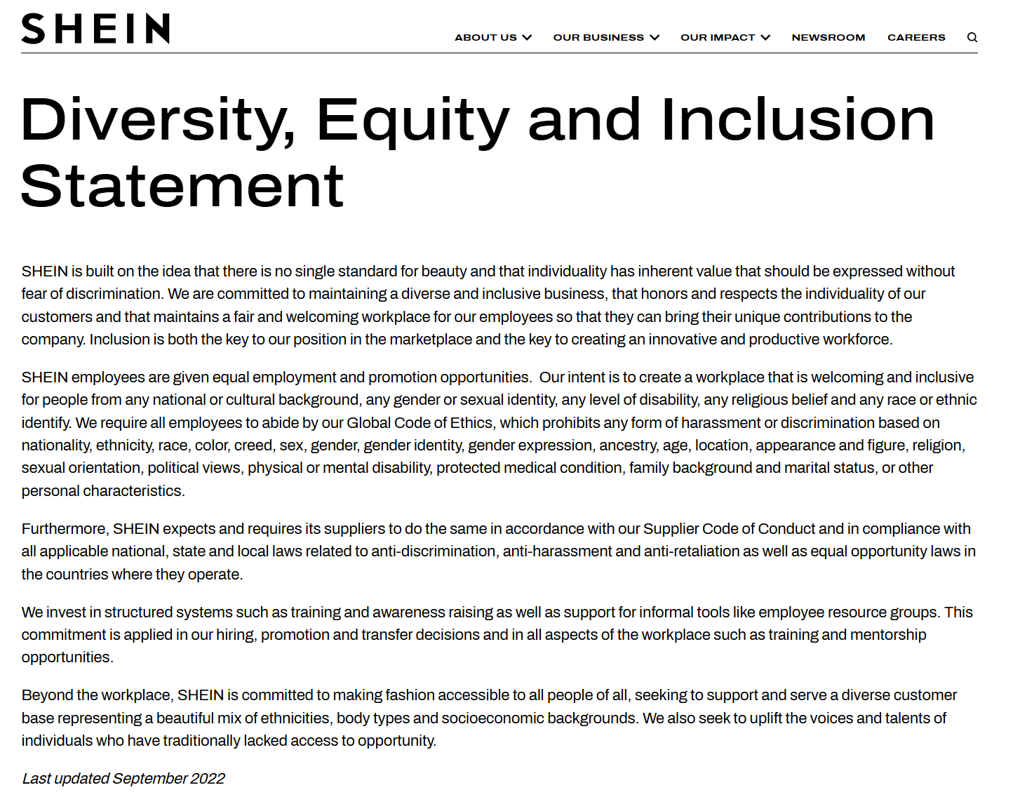

The first paragraph of the statement can be seen as a declaration of pluralism. Shein emphasized the philosophy of dealing with DEIB: “there is no single standard for beauty and that individuality has inherent value that should be expressed without fear of discrimination ". Shein highlighted the approach to inclusivity: “both the key to our position in the marketplace and the key to creating an innovative and productive workforce.”

It can be seen from this manifesto that Shein's management paradigm on diversity should be "***learning-and-effectiveness paradigm***". So, what about their practice and implementation? This report will be explained in the following sections【9】【10】【11】.

## Diversification strategy

The remaining paragraphs of the statement can be seen as its DEI strategy.

After collating, this report proposes 4 pre-project diversification strategies. The following are the contents and results of the strategy

1. Employee strategy: Equal opportunities and support

Shein claimed that by giving employees "equal employment and promotion opportunities," they exemplified the "discrimination-and-fairness paradigm" of a diversity management strategy, It is a concept of equality based on liberalism and aims to maintain equality of opportunity. However, this paradigm and concept mainly focus on formal equality, such as equal recruitment opportunities and salary treatment, while ignoring deep structural inequality, such as glass ceiling and racial discrimination.

Shein claims to have invested in "structured systems such as training and awareness raising as well as support for informal tools like employee. resource groups ". This can be seen as a kind of personal growth and support and encouragement for employees.

2. Supplier strategy: comply with local requirements, because non-compliance is directed

Shein asked suppliers to "do the same in accordance with our Supplier Code of Conduct and in compliance with all applicable national, state and local laws related to anti-discrimination, anti-harassment and anti-retaliation as well as equal opportunity laws in the countries where they operate." The success of Shein company is inseparable from a strong supplier and supply chain layout, however, Shein does not put forward higher requirements for the legitimacy of suppliers, ESG, DEIB and human rights protection. In addition, Shein has been repeatedly criticized for serious overtime problems at its Guangzhou manufacturing plant. In 2023, Shein caused controversy because its products were detected to contain Xinjiang cotton, and many countries and groups believed that this reflected Shein's oppression and forced labor of the Uyghur people, including the United States Congress, the American National Justice to Save the Uyghur Campaign team, and the British organization "Stop the Uyghur Genocide" made clear calls to boycott【12】【13】【14】.

3. Customer strategy: Pay attention to customer diversification

Shein claims to be working on "making fashion accessible to all people of all, seeking to support and serve a diverse customer base representing a beautiful mix of ethnicities, body types and socioeconomic backgrounds ". This demonstrates Shein's value and focus on customer diversity, in line with its diversity manifesto.

4. Talent strategy: Encourage people who lack opportunities

In the last sentence of the diversity statement, Shein claimed they were committed to "plift the voices and talents of individuals who have traditionally lacked access to opportunity”, This reflects the importance they place on talented people who lack opportunities because they are marginalized or discriminated against.

However, in 2021, Shein's factory and warehouse job ads said that "people from ethnic minority backgrounds, including Uighurs, are not allowed to apply."【15】

## Pain Points & Potential Problems

### A vast chasm between DEI announcement and real practices

There is a huge gap between Shein's statements on diversity and her practice. On the official website of the company, we can feel that the company tries to create a diverse, inclusive and fashionable atmosphere for visitors; Shein's social media promotion also focuses on its many styles, low prices and perfect service. Shein's manufacturing facility, however, is a different story【16】.

This report refers to this gap as "A vast chasm". Inside the Shein company, managers, designers, senior technicians have a free, comfortable, pleasant working environment, high job satisfaction and a good work-life balance, while textile workers and other employees in the supply chain are subject to oppression and forced labor. There are reports that workers at Shein's factories in China work more than 75 hours a week, face extremely high (2/3 of a day's pay) fines for mistakes, no basic pay and very low piece rates【17】.

These regulations and practices have been captured by many media and ngos. For example, an undercover investigation by Channel 4 and The i newspaper found that female factory workers in Guangdong, China, had so little time left to wash their hair during lunch breaks. Public Eye interviewed six workers at factories in southern China and noticed that Shein's factory had 14- and 15-year-olds.

Switzerland's Clean Clothes Campaign, which has visited some of Shein's factories, sees a "direct correlation" between long working hours and the piecework wage system that is common in China. They also found no emergency exits and Windows with iron bars, which is at odds with Shein's diversity statement to "provide a safe, hygienic and healthy working environment."

### Cross-cultural management of multinational corporations

As a global fast fashion retailer, Shein operates in a complex and diverse international market. This presents numerous cross-cultural management challenges. One significant issue is the varying labor laws and standards across different countries. Ensuring compliance with these regulations while maintaining a consistent supply chain can be particularly challenging. Moreover, cultural differences in business etiquette, communication styles, and decision-making processes can hinder effective collaboration between headquarters and international teams.

Additionally, managing a geographically dispersed workforce can lead to challenges in team building, motivation, and performance evaluation. Language barriers and time zone differences further complicate communication and coordination. What's more, Shein must navigate the complexities of global supply chains, ensuring ethical sourcing and production practices while mitigating risks associated with geopolitical events and trade disputes.

What is more noteworthy is that Shein is manufactured and sold in different countries. China, where its products are primarily manufactured, has a huge cultural difference from its main market of sales, especially in the workplace. For example, China's low compliance with labor and human rights laws, and the prevalence of overtime work and oppression of workers are unacceptable to the West, especially in Europe and the United States.

With the rise of "we media", some Shein factory employees began to share their work on personal media. The sharing wasn't entirely negative, but it was mostly filled with "sarcasm and dark humor." In fact, such content and attitudes toward work are more common in China, but users in the markets Shein sells to may not think so.

### Cultural issues unique to the fashion industry

**Cultural issues unique to the fashion industry**

Shein claims to cater to and respect different customer needs, but the unauthorized use of elements from other cultures, especially those with religious or historical significance, can easily be seen as disrespectful to the original culture and even commercial exploitation of it. In 2022, Shein was questioned by Mexico over his use of Mayan cultural symbols. The problem is compounded by the difficulty of understanding cultural differences; Different cultures interpret colors, patterns, and symbols differently, and a lack of sensitivity can lead to misunderstanding and alienating local consumers.

Balancing globalization and localization is another key challenge for Shein. While promoting a unified brand image globally, companies must also respect and integrate into local cultures, which requires careful navigation to avoid cultural appropriation. In the fast fashion industry, where rapid product turnaround is a hallmark, maintaining cultural sensitivity while promoting design innovation is a constant challenge. In addition, today's consumers are more culturally aware and less tolerant of cultural appropriation, and social media amplifying such controversies can cause serious damage to a brand's reputation【18】.

## Shein's Evaluation of diversification strategy

### Comments from internal managers

On Shein's official website, Aline, Business Administrator, Dublin says "In one word, SHEIN’s team is diverse. The reason is that diversity within the team brings together individuals from various cultural, ethnic, and educational backgrounds, which enhances the team’s ability to approach challenges from different angles. This visibility also promotes a culture of inclusion where everyone’s voice is valued and respected.”【20】

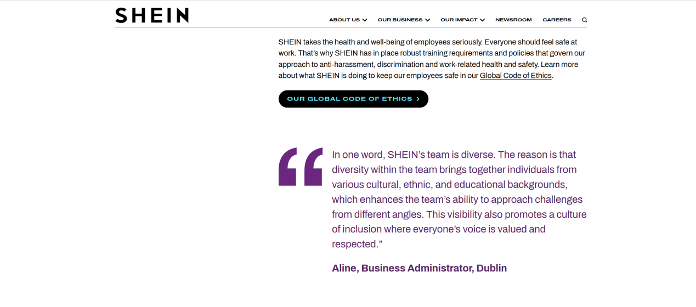

Shein thinks they are doing well in terms of the number and status of female managers. To hone in on the ways in which women have made a positive, impactful change in the workplace for Women’s History Month, SHEIN is honoring its female leaders by having them share personal stories and anecdotes on what leadership means to them. With women making up over 56% of their global workforce, the fashion company’s leaders cite that change can be enacted through: empowering conversations that uplift rather than tear down, creating a safe space that allows for open dialogue and constructive feedback, developing programs and partnerships with female entrepreneurs through its SHEIN X program and college students through its Campus Ambassador program as a way to create opportunities along with ways in which its leadership can pave the future forward.

On International Women's Day 2023, Shein held a celebration and published an article in hypeae praising the company's female managers【21】.

“We want our employees, especially women and regardless of title, to feel empowered to speak up in times of adversity, contribute ideas and make great decisions in their roles that will leave a lasting impact on the brand,” said Maxine Silva, senior director of brand PR. “These are important factors towards a more equitable future,” she adds.

### Shein’s Metrics

In Shein's 2023 Sustainability and Social Impact Report【19】, Shein reports on some of their successes in organizing diversity and promoting diversity, equality, and inclusion in the world. Shein mainly quantifies her achievements in diversity development and social responsibility through specific figures in the report.

In the report, Shein demonstrates excellent employee diversity, with 55% of Shein's global workforce being women and 40% of its senior management ranks being women. About 49 percent of its employees are under the age of 30, which gives Shein an excellent company dynamic.

Shein is also active in social responsibility, supporting workers and their families by establishing child care centers in 10 supplier facilities and providing financial assistance to 165 workers' families through the SHEIN Spotlight Program. These measures demonstrate Shein's commitment to employee welfare and community support.

Through these specific indicators and outcomes, Shein is able to quantify its progress in social responsibility and diversity development and provide direction for future improvements. These efforts reflect not only Shein's emphasis on diversity within its own workforce, but also its commitment to diversity and inclusive practices in its global supply chain, thereby driving a more equitable and sustainable fashion industry worldwide.

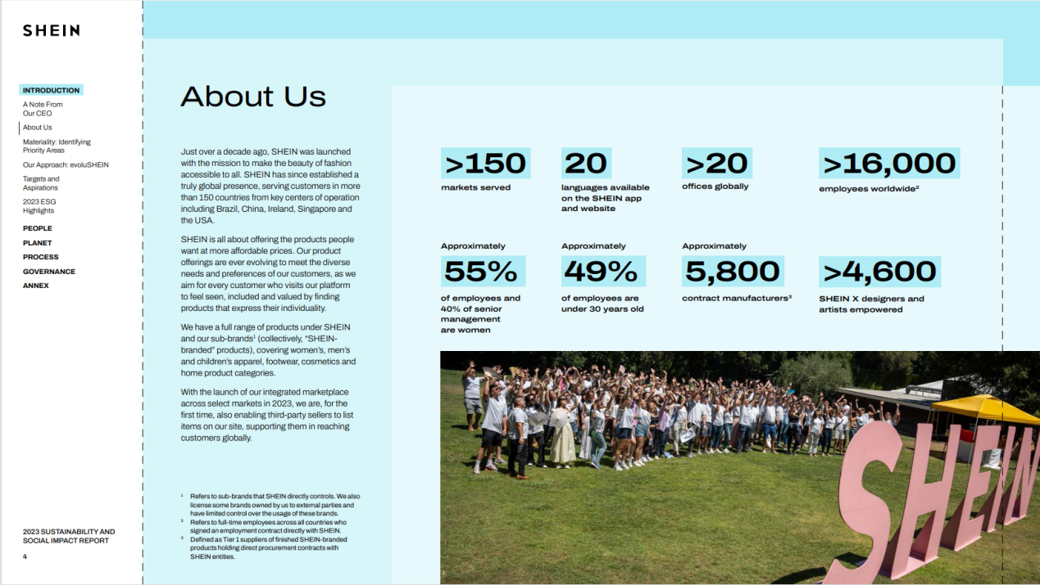

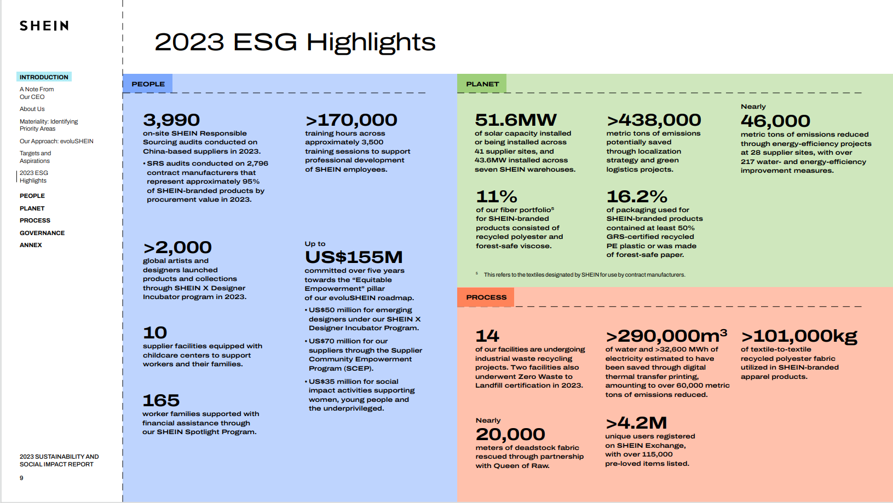

### Employee satisfaction data

1. **Overall Diversity, Equality and Inclusion (DEI) score**

Overall rating: 3.4, slightly above the industry average, but still not excellent.

Employee feedback:

- Asian employees: 2.9

- African-American employees: 1.4

- Hispanic workers: 3.1

- Men: 2.4 points

- Female: 2.8 points

- Heterosexual: 2.5 points

- LGBTQ+ group: 1.5 points

It should be noted that the African-American and lgbt communities do not consider shein to be sufficiently diverse【22】.

1. **Promotion policies and opportunities**

**Promotion frequency:** According to the data, only 6% of employees say they get a pay raise every quarter, while 41% say they "never" get a pay raise. This may indicate that there is a certain imbalance in the promotion and salary promotion of SHEIN, which may lead to some groups facing obstacles to career development.

**Promotion policy:** 31% of employees strongly disagree with a policy that prioritizes internal promotion over external hiring, while only 8% strongly agree. This may reflect differences and dissatisfaction in the implementation of promotion policies, which may affect the promotion opportunities of certain groups【23】.

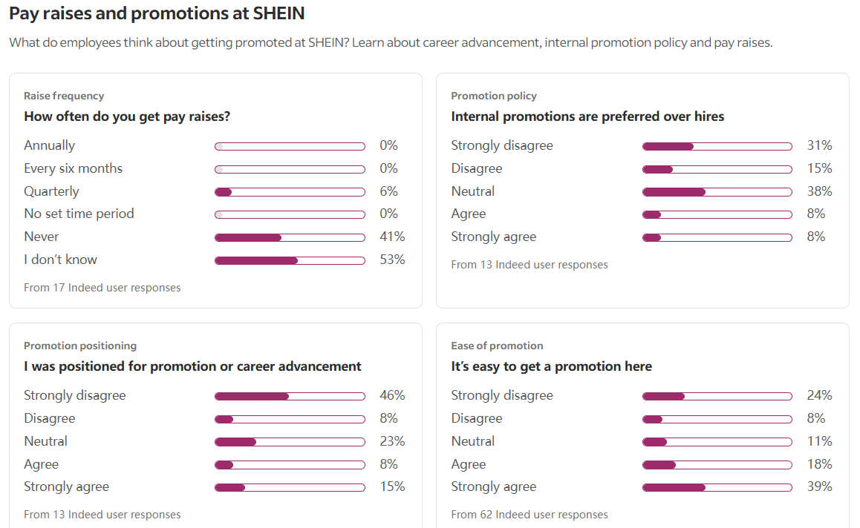

**b .1 Training and skills development**

**Training opportunities:** 70% of employees said they had training opportunities, while 30% said they did not. This shows that SHEIN provides training opportunities for the majority of its employees, but there is still room for improvement, especially for the 30% of employees who do not have training opportunities【24】.

**Learning development Budget:** 45% of employees said they had a learning development budget, while 55% said they did not. This can mean that there is an imbalance in the company's investment in supporting the personal development of employees, which may affect the career development of some employees.

**b.2 Company culture and management**

**Decision-making autonomy:** 44% of employees strongly disagree that they have enough autonomy to make decisions. This may indicate a tendency to centralize decision making in company culture and management practices that may affect employee engagement and ability to innovate.

**Manager Evaluations:** 41% of employees rated their immediate manager as "poor," while only 24% rated them as "excellent." This may indicate management issues with leadership and employee relations that can affect collaboration and promotion in diverse teams【25】.

1. **Pay differentials and DEI diversity analysis**

**Pay differentials:** SHEIN's pay analysis shows significant differences in pay across roles and tiers. Senior positions such as director of Global brand operations and senior algorithm engineer pay significantly more than lower-level positions such as interns and administrative assistants. This may indicate that there is a "sticky floor" phenomenon in SHEIN, that is, certain groups have encountered obstacles in their career development, and it is difficult to get promotion and corresponding salary increase.

**DEI Diversity Analysis:** There is a lack of data on diversity indicators such as gender, ethnicity or background, which can lead to income and career development imbalances between different groups. Further data transparency and DEI practices will help drive a more inclusive compensation system, enabling companies to achieve fair pay and growth opportunities across all groups. To sum up, SHEIN has certain imbalance and problems in promotion policies, training opportunities, pay differences and other aspects, which may affect the realization of diversity. Companies need to further improve these areas to ensure that all employees have equal career development opportunities and pay packages.

1. **Include diversity in your interview**

**d.1 Interview analysis and job seeker experience**

Interview Difficulty and feedback: SHEIN's interview difficulty score is 2.7 out of 5, with 41% of candidates giving positive feedback, indicating that most candidates are positive about the interview experience. However, 30% of negative feedback indicates that there is still room for improvement.

Sources of interviews: 75% of candidates were interviewed through online applications, 13% were contacted by recruiters, 5% were referred by employees, and the rest were from other sources. This shows SHEIN's diversity in recruitment channels, but also points to the low percentage of referrals through employees, which may affect employee diversity【26】.

**d.2 Diversity in the hiring process**

Job Diversity: The high number of interviews for positions such as interns, customer service representatives and product managers shows that SHEIN is actively hiring at all levels, which helps candidates from different backgrounds come in.

Cultural and Background diversity: SHEIN strives to attract candidates from diverse backgrounds at the technical and managerial levels. One algorithm engineer noted that the diversity of SHEIN's culture is reflected in colleagues with strong business acumen and adaptability. However, there were also employees who expressed concerns about diversity, especially in certain regions and positions, such as warehouse employees in Toronto who cited unprofessional management and a lack of diverse teams.

Potential discrimination issues: According to the bbc, shein's refusal to hire Uyghurs and ethnic minorities in Xinjiang could be a huge blow to shein【27】【28】.

1. **Summary**

SHEIN is committed to creating a diverse and inclusive business environment that respects and values the uniqueness of individuals, but in actual implementation, according to the above reported data, the company still has diversity and inclusion issues【29】.

## Third-party evaluation of Shein on DEIB and ESG

### GOOD ON YOU: We avoid!

According to information On the Good On You website, Shein's performance in sustainability and ethics was rated "We Avoid" based on its score in three areas: environment, workers' rights and animal welfare. In the People (human rights) area, it was even rated "Very Poor" with a score of 1/5.

Good On You lists the following evidence:

It only scored 0-10% in the Fashion Transparency Index 2022.

There is no evidence that providing financial security to suppliers can lead to poor working conditions and low wages.

There is no evidence to support diversity and inclusion in supply chains.

Some suppliers were audited, but there was no evidence to ensure that workers in the supply chain were paid a living wage.

During the COVID-19 outbreak, insufficient policies or protections were disclosed to protect workers in the supply chain from the virus.

This contradicts Shein's official statements about the importance they attach to human rights.

Shein claims on their website that they"

Enable Self Expression for All

Provide Access to Talent

Improving Lives in Communities." 【30】【31】

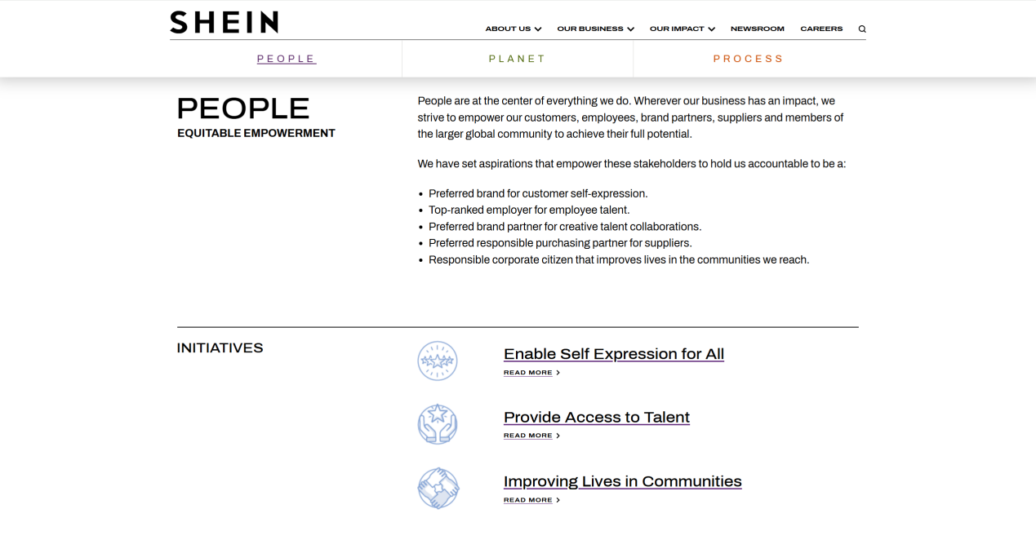

# New DEI Strategy:

## Mission & Vision

### Mission Statement

Our mission is to make the beauty of fashion accessible to all，reimagining fashion by leveraging our small-batch on-demand production model. This innovative, customer-driven model allows for more choice at more affordable prices while minimizing overstocking of goods and waste, authorizing suppliers and unblocking supply chains by measuring customer preferences more accurately and efficiently. Look at the global market with a more diverse perspective, break down barriers between global markets, unblock global supply chains, and enable people from different parts of the world to experience the beauty of fashion. Absorb the fashion cultural experiences and concepts from the global market, so that people can appreciate the beauty of fashion from all over the world.

### Vision Statement

Our vision is to not only to follow the market direction, but also to accurately predict the market direction, additionally to lead the market fashion direction; not only to quickly provide what customers want, but also to predict and prepare what customers want in advance, additionally to become the market leader, so that customers' wishes to our progress as the standard. It's a vision we've worked toward since 2012 by empowering customers, creators, independent suppliers and individual entrepreneurs.

## Goals and Objectives

### Objectives

Our objective is to foster a more diverse and inclusive workplace by increasing representation, promoting equal opportunities, and creating an environment where all employees feel valued and supported.

### Smart Goals

Within the next six months

SHEIN will establish the DEI team to launch a quarterly multicultural and inclusion training program to ensure management and employee participation reaches 80%. At the same time, an employee satisfaction survey was launched, focusing on African-American, LGBTQ+, women, and minority employees to collect baseline data, establish an annual feedback mechanism, and produce a preliminary analysis report.

Within the next year

SHEIN will reduce overall employee attrition by 10 percent by improving promotion and compensation policies to raise satisfaction scores for black and LGBTQ+ employees to at least 3.0, and ensure that women and minorities are promoted to at least 15 percent. In addition, complete the implementation of a career mentorship program in which at least 50% of female and minority employees participate in order to enhance their career opportunities.

In the next two years

SHEIN will establish a systematic and inclusive promotion pipeline, increase African-American and LGBTQ+ employee satisfaction scores above 3.5 each, and ensure that women and minorities make up 70% of their overall representation in management and senior positions at the company. Through continuous DEI data tracking and performance evaluation, strive for "Best Workplace for Diversity" or similar industry awards to enhance the company's brand image and global market competitiveness.

## Action Plans

SHEIN’s DEI action plan will unfold over two years: in the first 6 months, establish a DEI team, begin quarterly training, and conduct baseline surveys; by 12 months, launch mentorships, revise hiring and promotion policies, and set measurable DEI goals like raising minority satisfaction scores to 3.0 and reducing turnover by 10%; and by 24 months, enhance promotion pathways, increase representation by 15% in management, and seek DEI recognition. Throughout, we’ll adjust initiatives to local legal and cultural needs, while allocating an annual DEI budget of $950,000 to support training, mentorships, data tools, and recruitment efforts.

## Leadership Commitment

### Practices

#### Communicate a diverse strategy and overall mission at the leadership level

Leadership clearly communicates the organization's diversity strategy and mission, ensuring that all employees understand and share these goals, thereby driving cultural change across the organization.

#### Set a Superordinate goal of diversity

Create a common goal that transcends individual or departmental interests that all employees can identify with and work towards, thereby reducing internal conflict and enhancing teamwork.

#### Set up a Diversity Committee

A dedicated diversity committee is established to oversee and drive the implementation of diversity policy to ensure that the organization is effectively advancing its diversity goals at all levels.

#### Establish a diversity manager and diversity department

Designate a dedicated diversity manager and establish a diversity department responsible for developing and implementing specific diversity programs and ensuring that these programs are effectively implemented and monitored.

#### Incorporate diversity metrics into management assessment

Incorporate diversified indicators into the performance appraisal system of managers to ensure that managers attach importance to and promote the realization of diversity goals in their daily work.

#### Develop affirmative action programs

The implementation of affirmative action plans, through specific measures and policies, to ensure that all employees, especially minority groups and disadvantaged groups, can have equal opportunities and development space.

#### Regular ESG reports are published

Regularly publish environmental, Social and governance (ESG) reports that transparently disclose the organization's progress and challenges in diversity and social responsibility, and enhance the trust and support of external stakeholders.

### Relevant theories and evidence

Research by Kathleen M. O'Reilly, Jennifer R. Chatman, and David A. Caldwe shows that employees are more likely to collaborate across cultural and background differences when organizations identify and emphasize shared goals【32】.

Institutional Theory is a theoretical framework for explaining organizational behavior and change. The theory holds that the behavior and structure of organizations are influenced by the social institutions and norms in which they operate, including laws, rules, values, and culture【33】. According to the institutional theory, organizations will be under the pressure and restriction of these institutions and norms during their formation and operation, which will prompt organizations to adopt specific behavioral patterns and strategies to adapt to and conform to social expectations, so as to obtain legitimacy and stability】【34】【35】.

### Keep up with company strategy

## Training & Development

### Relevant theories and concepts

#### Social Learning Theory

Social Learning Theory, developed by Albert Bandura, emphasizes that people learn by observing the actions and outcomes of others. Bandura pointed out that individuals not only acquire new behaviors through direct experience, but also acquire knowledge and skills by observing and imitating others【36】.

- Bandura, A. (1977). \*Social learning theory\*. Prentice Hall.

#### Adult Learning Theory

Adult Learning Theory, developed by Malcolm Knowles, emphasizes the importance of self-direction and experience in adult learning. Knowles noted that adult learners tend to be more self-directed, goal-oriented, and relate learning to real-life problems【37】.

- Knowles, M. S. (1984). \*The adult learner: A neglected species\* (3rd ed.). Gulf Publishing.

#### Experiential learning theory

Experiential Learning Theory, developed by David Kolb, views learning as a four-stage cycle based on experience, consisting of concrete experience, reflective observation, abstract conceptualization, and active experimentation. Kolb believes that through this circular process, learners can extract knowledge from experience and gradually develop new concepts and skills.

- Kolb, D. A. (1984). \*Experiential learning: Experience as the source of learning and development\*. Prentice Hall.

#### Culture business

Cultural Intelligence (CQ) refers to an individual's ability to adapt and operate effectively in cross-cultural situations. Cultural quotient consists of four dimensions: cognition, emotion, motivation and behavior, which helps people communicate and collaborate effectively in a multicultural context. Thomas and Inkson point out that people with high cultural quotient are able to understand and adapt to different cultural behavior patterns and promote cross-cultural communication and cooperation【39】.

- Earley, P. C., & Ang, S. (2003). \*Cultural intelligence: Individual interactions across cultures\*. Stanford University Press.

#### Unconscious bias Theory

Unconscious Bias Theory is the study of unconscious cognitive biases in individuals that often influence decision-making and behavior. Unconscious bias arises through social and cultural influences and can lead to unfair evaluations of different groups【40】.

- Banaji, M. R., & Greenwald, A. G. (2013). \*Blindspot: Hidden biases of good people\*. Delacorte Press.

### Training content:

Unconscious bias: Help employees identify and overcome unconscious bias.

Cross-cultural communication: Develop the ability of employees to communicate effectively in different cultural contexts.

Inclusive: Create an inclusive work environment where all employees feel respected and valued.

Diverse team building: Develop the ability of employees to collaborate in diverse teams.

Global perspective: Broaden employees' global perspective and let them understand the differences and similarities between different cultures.

### Training activities & Development Practices

Invite outside experts: Invite experts from different cultural backgrounds to give lectures or training.

Immersive cultural Exchange programs: Implement cultural immersion programs to improve the cultural intelligence of employees and managers

Scenario simulation and negotiation simulation: improve the ability of employees and managers to cope with cultural conflict, and communication skills

Online test: Test employees' unconscious biases and improve their awareness of diversity and cultural mindfulness

Talent development planning: Provide the most suitable development planning for all groups of employees to promote the growth of employees

Career development incentive: Combine the incentive theory to improve the diversified motivation of employees and managers

Diverse team projects and case learning: Integrated with adult learning theory, it emphasizes adult learners' autonomy, experiential richness, and problem-centered learning characteristics. In training, problem-oriented learning activities can be designed to encourage employees to apply their experience to solve problems.

World Cafe: Combining social learning theory, small discussion groups are organized to conduct in-depth exchanges on diverse topics.

Invite experts or excellent staff to give lectures.

Global Cultural Festival: A global cultural festival is held every year to allow employees from different countries and regions to share their own culture, such as food, music, dance, clothing and so on.

Virtual reality cultural tour: Using VR technology, employees can experience the cultural customs of different countries and increase the intuitive feeling of diverse cultures.

Global Volunteer Projects: Encourage employees to participate in global volunteer projects, such as environmental protection, education, etc., to increase their understanding of global issues.

Diversity Fashion Design Competition: Employees are encouraged to design clothes that reflect multicultural elements, and competitions are held, and the winning works can be used in actual production.

Fashion Culture Seminar: Fashion designers and cultural scholars from different cultural backgrounds are invited to share and exchange ideas.

## Talent Acquisition & Retention

### Establishment of global diversified talent pool

Expand recruitment channels: not only limited to traditional recruitment channels, but also actively expand cooperation with diversified talent organizations, universities and social media to establish a broad talent network.

Global Recruitment events: Regular global recruitment events are held to attract talented people from different countries and backgrounds.

Language proficiency requirements: Flexibly adjust language proficiency requirements and encourage talents with multiple languages to join.

### Local recruitment strategies

In-depth knowledge of the local labor market: fully understand the characteristics of the local labor market, laws and regulations, cultural practices, and the representation of different groups in the job market.

Work with Local communities: Build partnerships with local communities, participate in community events, increase brand awareness, and attract local talent.

Localization of recruitment process: Adjust recruitment process and evaluation criteria according to local laws, regulations and cultural customs.

### Management of cultural differences

Cultural training: Provide cross-cultural training for all employees to help employees better understand and respect different cultural backgrounds.

Build a diverse team: Encourage the establishment of a diverse team, so that employees from different cultural backgrounds learn from each other and grow together.

Inclusive work atmosphere: Create an inclusive work atmosphere so that all employees can feel a sense of belonging.

### DEIB considerations in the recruitment process

Bias free hiring process: Optimize the hiring process to remove factors that may lead to discrimination and ensure fairness in the hiring process.

Diverse Team of interviewers: Assemble a diverse team of interviewers to reduce the impact of a single perspective on hiring results.

Blind selection: During the resume screening stage, consider blind selection and hiding candidates' personal information to reduce bias.

### Balance between local and non-local employees

Balance localization and globalization: While ensuring localized recruitment, it is also necessary to attract outstanding talents from other countries to achieve a global talent structure.

Establish a fair promotion mechanism: Establish a fair promotion mechanism to provide equal promotion opportunities for all employees.

Cross-cultural exchange platform: Establish a cross-cultural exchange platform to promote communication and cooperation between local and non-local employees.

### Compliance with laws and regulations

Familiar with local laws and regulations: Have a detailed understanding of local laws and regulations on recruitment, employment, discrimination, etc., to ensure that recruitment practices are legal and compliant.

Hire legal counsel: Hire professional legal counsel to provide legal advice to the company and ensure compliance operations.

### Data-driven decisions

Establish diversity data metrics: Establish diversity data metrics to track diversity in the hiring process and regularly analyze the data to evaluate the effectiveness of DEIB's strategy.

Data-driven improvement: Based on the results of data analysis, constantly improve the recruitment strategy and improve the effectiveness of DEIB.

## Partnerships & Collaboration

SHEIN's strategy to achieve diversified partnerships in different fields such as suppliers, non-governmental organizations, diversified models, and independent designers should focus on inclusive cooperation and shared values. This method can be guided by the following strategies:

#### Supplier Diversity:

SHEIN can prioritize establishing partnerships with suppliers who are committed to ethical practices and sustainable development. By establishing standards that reflect social responsibility and environmental management, SHEIN ensures that its supply chain aligns with the values of its target consumers, fostering trust and loyalty. This is consistent with the broader industry trend emphasizing ethical procurement.

#### Collaboration with non-governmental organizations:

Collaboration with non-governmental organizations enables SHEIN to participate in meaningful social activities that resonate with its brand image. Choosing non-governmental organizations that focus on issues related to their population, such as women's empowerment, environmental sustainability, or community development, can enhance SHEIN's corporate social responsibility image and have a positive impact on the communities they serve.

#### Diversified Model Selection:

When selecting models, SHEIN should prioritize diversity and representation to reflect its global customer base. Collaborating with models from different backgrounds not only aligns with the social justice movement, but also attracts a wider audience and enhances the brand's relevance.

#### Empowering independent designers:

By actively seeking and supporting independent designers, SHEIN can explore unique creative perspectives and trends. This strategy not only promotes innovation, but also cultivates a sense of community in the fashion industry, making SHEIN a leader in supporting emerging talents.

**1. How to solve the current problem and improve the existing DEI strategy?**

To address SHEIN's current DEI issues and improve its strategy, we will take the following steps:

**Increase diversity channels:** Expand recruitment channels and work with diversity recruitment platforms, community organizations and universities to attract more minority, LGBTQ+ and female applicants.

**Optimize promotion and compensation policies:** Based on employee feedback, adjust existing promotion and compensation systems to ensure that women and minority employees have fair career opportunities.

**Provide targeted inclusion training:** Conduct quarterly training on cross-cultural communication, unconscious bias, and teamwork to help employees better understand and accept diversity.

**Set up a DEI team and feedback mechanism:** Set up a DEI team responsible for driving improvements and regularly collecting and improving the effectiveness of strategies through employee feedback mechanisms.

**2. Is the strategy consistent with the current business strategy? If not, how do you adjust to achieve consistency?**

The DEI strategy is largely aligned with SHEIN's global business strategy, as it emphasizes multicultural perspectives and cross-cultural collaboration that help break down global market barriers, enhance brand influence and better serve global customers. However, if further alignment is needed, we can enhance consistency by:

Focus on global customer needs: Gain more market insights through a diverse team and design products to meet the cultural preferences of different regions, thereby directly supporting the global development of the brand.

Enhance brand value: Through DEI awards and diversified image, enhance the competitiveness of the brand in the global market and attract more customers and partners.

Supporting local market expansion: Implementing DEI measures in each region, respecting and integrating with local cultural needs, so as to align more closely with SHEIN's global expansion strategy.

# Implementation:

**Implementation Plan for SHEIN’s DEI Strategy**

### a. How will the strategy be implemented?

SHEIN’s DEI strategy will be implemented in phases, with the DEI team leading the initiatives and collaborating closely with HR, training, and local country managers. This includes:

1. Establishing a dedicated DEI team and implementing a DEI-focused training program every quarter.
2. Conducting employee satisfaction surveys to gather baseline data and understand areas for improvement.
3. Implementing a mentorship program for women and minority employees, offering career growth support.
4. Revising hiring and promotion policies to prioritize diverse candidates for certain roles.

### b. How long will it take?

The strategy will be rolled out over two years:

* **0–6 months**: Form DEI team, start quarterly training, and conduct baseline satisfaction surveys.
* **6–12 months**: Begin mentorship programs, adjust promotion policies, and aim to increase satisfaction scores to at least 3.0.
* **12–24 months**: Strengthen promotion channels, increase representation at management levels, and work toward award recognition for diversity.

### c. What is the cost? What resources do you need?

The estimated costs include:

1. **DEI Team and Training**: Hiring a DEI director, supporting staff, and trainers – approximately $500,000 annually.
2. **Survey and Data Analysis Tools**: Software and resources for survey implementation and feedback collection – approximately $100,000 annually.
3. **Mentorship Programs**: Partnering with diversity-focused mentorship providers or developing an in-house program – estimated $150,000 annually.
4. **Recruitment Resources**: Budget for targeted advertising, job fairs, and partnerships with diverse hiring platforms – approximately $200,000 annually.

### d. Step-by-Step Plan for Recruiting and Hiring Practices

1. **Review Current Practices**: Analyze current hiring and recruitment practices and identify areas where underrepresented groups are not being reached or are leaving during the recruitment process.
2. **Expand Talent Pools**: Engage with diverse job boards, universities, and community organizations in each operating country to increase applications from underrepresented populations.
3. **Bias Training**: Implement mandatory training for recruiters and hiring managers to minimize unconscious bias in recruitment processes.
4. **Diverse Interview Panels**: Establish diverse interview panels to reduce bias and make the hiring process inclusive.
5. **Data-Driven Goals**: Set measurable targets to increase diversity at each stage of the recruitment funnel, from application to offer acceptance.
6. **Feedback Mechanism**: Collect feedback from diverse candidates on their hiring experience to continuously improve practices.

### e. Country-Specific Implementation Considerations

#### Local vs. International Workforce

SHEIN’s workforce consists of both local and international employees across various regions, with differing legal and cultural expectations. Adapting to these localities will involve:

* **Singapore**: Focus on including ethnic minorities and underrepresented groups. Expand local partnerships with organizations supporting diverse hiring.
* **United States and Europe**: Increased emphasis on LGBTQ+ inclusion and minority hiring, considering legal protections and diversity expectations in these markets.
* **Other Regions**: Partnering with local organizations to understand regional diversity concerns, which may include gender equality, ethnic inclusion, or specific legal quotas for native employees.

#### Legal and Regulatory Requirements

Each country has unique employment regulations:

* **Singapore**: Limited diversity quotas, but an increasing push for diversity in tech and fashion. Cultural sensitivity training will focus on fostering inclusion within local legal parameters.
* **United States and Europe**: Stronger DEI regulations, including quotas in some regions (e.g., gender quotas in the EU). Compliance will involve active recruitment for minority groups and equal employment practices.
* **Middle Eastern Countries**: Laws may restrict certain minority employment or impose restrictions on the type of work. Adapt DEI initiatives to be respectful and compliant with local norms and regulations.

#### Cultural Differences and Organizational Culture

* **Native vs. Nonnative Cultural Integration**: Training should address cultural awareness, especially as nonnative employees bring diverse perspectives that differ from local practices.
* **Reflecting Dominant Country Culture**: In regions like China, where company leadership is rooted, the organizational culture may lean toward native practices. Adapting a more inclusive culture that reflects SHEIN’s global employee base will be essential to creating a cohesive workplace.

**1. Are they mainly local employees, or do they come from other countries as well?**  
SHEIN’s workforce primarily consists of local employees in each operational region, with some international employees in managerial and specialized roles. This composition allows SHEIN to tailor its workforce to each market’s local needs while bringing in global perspectives where necessary.

**2. Are there any laws, regulations, quotas, etc., regarding the employment of local groups?**  
Yes, each country where SHEIN operates has unique regulations related to local group employment. For example:

* **Singapore** has fewer formal DEI quotas but has been pushing for more inclusive hiring practices, especially in tech and manufacturing sectors.
* **European Union countries** often have stringent DEI laws, including quotas for female representation on boards and requirements to reduce gender pay gaps.
* **United States** enforces anti-discrimination laws such as the Equal Employment Opportunity Act, and many states have additional requirements for LGBTQ+ inclusion and minority hiring practices.

**3. Take into account major cultural differences between native and nonnative employees.**  
Cultural differences often impact communication, teamwork, and management styles. Local employees may have established workplace norms, while nonnative employees might bring varying perspectives:

* **Communication**: Local employees may be accustomed to specific hierarchical communication styles, while nonnative employees might expect a more collaborative or open dialogue.
* **Work-Life Balance**: Expectations around work hours and flexibility can vary, with local norms sometimes favoring longer hours or a stricter work structure.
* **Management Styles**: Nonnative employees may be used to more inclusive management practices, contrasting with local employees’ familiarity with hierarchical structures.

**4. Is the dominant country culture reflected in the culture of this organization?**  
Yes, SHEIN’s organizational culture is influenced heavily by Chinese business practices, especially in its headquarters. This is reflected in the hierarchical structure, decision-making processes, and management style. However, as SHEIN grows internationally, it’s increasingly adopting diverse cultural elements to create a more inclusive environment that resonates with its global workforce. Efforts are ongoing to blend the dominant country culture with an adaptable, inclusive culture that reflects the varied backgrounds of its employees across different regions.

# Metrics

1. **How will you measure the success of the strategy?**

Establish key Performance Indicators (KPIs)

• Diversity metrics: Set goals, such as increasing the proportion of women or minorities in the workforce by a certain percentage within a year, and analyze whether they are met. Indicators include gender, ethnicity, the proportion of employees from different backgrounds and changes in job distribution.

• Hiring and Retention: Tracks hiring, retention, and promotion rates for employees from a variety of backgrounds, with a particular focus on the diversity of higher-level positions. Set a baseline value and observe how retention rates fluctuate after the implementation of DEI improvements.

• Pay equity: Examines pay equity for the same ranks and tracks progress in the pay equity improvement plan. This can be done by analyzing gender and race pay gaps to identify potential problems.

Employee feedback and satisfaction surveys

• Conducts an annual DEI survey: An anonymous survey collects employee feedback on DEI measures, including work environment, cultural inclusion, availability of resources, and belonging. Design questions such as "Do you feel you have equal opportunities and support?" .

• Conduct focus group interviews with employees from a variety of backgrounds to gauge their true feelings about the company's inclusive culture and their feedback on improvements, thereby obtaining qualitative data to guide subsequent adjustments.

Observe cultural and behavioral changes

• Analyze daily communication and collaboration: Use regular observations and manager feedback to identify whether teams are collaborating more across cultures and contexts. Some "360-degree feedback" can be used to get an objective evaluation of inclusiveness and communication from the team.

1. **Show how your strategy will benefit the company’s goals of profits and growth, legitimacy, and high performing teams.**

**Impact on profit growth**

1. Reduce attrition rates and hiring costs

• With effective implementation of diversity, Equality and inclusion (DEI) strategies, companies can significantly reduce employee turnover, especially among groups such as minorities and women. When employees feel an inclusive culture in an organization, they are more likely to stay with the company for the long term, reducing the high costs associated with frequent hiring. Research has shown that the reduction of attrition rate not only helps to save recruitment costs, but also improves the stability and efficiency of the team, thus supporting the long-term goal of the company in cost control.

2. Productivity and innovation assessment

• Diverse teams are more innovative and creative because of their rich perspectives, which drives the overall productivity of the organization. For example, members from different cultures and backgrounds bring different ideas and solutions to the table, and this diversity of perspectives leads the team to produce more effective problem solving. In addition, a diverse environment is more conducive for employees to come up with innovative suggestions in an open and inclusive atmosphere. Research shows that the number of innovative proposals made by employees is closely related to the inclusive atmosphere of diverse teams, and the quality and effectiveness of these proposals are also higher, contributing to business growth and market expansion.

3. Market expansion

• When it comes to market expansion, diverse teams gain better insight into the needs of diverse customer groups. For example, employees with different cultural, gender, or ethnic backgrounds have a better understanding of the preferences of these specific populations and can develop marketing strategies that are more tailored to their needs. In this way, the company can quickly enter and steadily develop new markets and improve customer satisfaction. In addition, companies with diverse workforces tend to gain the trust of various groups more easily, resulting in a broader customer base and loyalty that helps maintain a competitive edge in a global marketplace.

**Enhance legitimacy and brand value**

1. Industry certifications and awards

• Companies that successfully implement DEI strategies stand a better chance of receiving industry recognition such as the "Best Place to Work for Diversity" and the "Inclusive Business Award." These awards not only enhance the appeal of the company's brand, but also become a powerful tool to attract high-quality talent. This external recognition, especially from authoritative organizations, can bring more media exposure opportunities for enterprises, further enhance brand awareness and corporate reputation, and enhance the trust and acceptance of customers and the market.

2. Customer and partner feedback

• Diversified companies tend to build a better reputation with customers and partners. Customers and partners are more inclined to work with companies that have an inclusive culture because they not only meet a wide range of needs in their products and services, but also demonstrate a positive attitude towards social responsibility. Feedback from customers and partners on the company's DEI strategy can be collected regularly through questionnaires, interviews and other means, and the effect of such feedback on improving the company's brand image, customer loyalty and market influence can be tracked.

**High performance team building**

1. Team performance data

• Diverse teams generally show stronger cross-cultural collaboration and higher task completion efficiency. Based on The problem-solving Argument, team members from different backgrounds can provide diverse perspectives on The Problem, and the collision of different cultures in the team is more likely to stimulate new ideas, thus improving the quality of decision making. Quantitative analysis of team task completion efficiency, innovation results, and communication and collaboration data allows for a more comprehensive assessment of the contribution of diversity to high team performance.

2. Staff development opportunities

• In an inclusive culture, employees from different backgrounds have more opportunities for fair career development, which helps build high-performing teams. By setting clear promotion metrics that measure the training and promotion progress of diverse employees, companies can not only motivate more minorities and women to enter senior management, but also enhance employees' organizational commitment. According to The Resource-Acquisition Argument, when a company treats the career development of its employees in a fair way, it will attract more talented people to join, achieve the "talent aggregation effect", and provide long-term competitiveness for the company's high-performing team.

3. Creativity and amount of innovation

• Diverse teams are often more innovative than monocultural teams, and members from different backgrounds can bring eclectic ideas and creative solutions. According to The Creativity Argument, this diversity of cultures and backgrounds brings multiple perspectives to the team, helping to break out of the box and enhance the atmosphere of team innovation. Companies can assess the degree to which DEI strategies incentivize innovation by measuring the number of innovative proposals made by diverse teams and the adoption rate, so as to better understand the role of diversity in promoting a company's innovation culture.

**Comprehensive evaluation method**

Through a comprehensive analysis of profits, growth, brand value, and team performance, companies can systematically assess the success and failure of DEI strategies. According to the above theory, setting diversified performance indicators and regularly evaluating DEI related data can not only improve the overall efficiency of the organization, but also provide a basis for long-term strategic adjustment, thus achieving significant improvement in organizational structure, innovation and market influence.

# Reference

1. Wikipedia. (n.d.). Shein. In Wikipedia. Retrieved November 1, 2024, from [https://zh.wikipedia.org/zh-cn/%E5%B8%8C%E9%9F%B3#cite\_note-43](https://zh.wikipedia.org/zh-cn/%E5%B8%8C%E9%9F%B3" \l "cite_note-43" \t "_new)
2. Shein. (n.d.). Shein at a glance. Retrieved November 1, 2024, from [https://www.Sheingroup.com/about-us/Shein-at-a-glance/](https://www.sheingroup.com/about-us/shein-at-a-glance/" \t "_new)
3. Wikipedia. (n.d.). Shein. In Wikipedia. Retrieved November 1, 2024, from [https://zh.wikipedia.org/zh-cn/%E5%B8%8C%E9%9F%B3#cite\_note-43](https://zh.wikipedia.org/zh-cn/%E5%B8%8C%E9%9F%B3" \l "cite_note-43" \t "_new)
4. Hofstede Insights. (2021, April 7). National culture. Retrieved November 1, 2024, from <https://hi.hofstede-insights.com/national-culture>
5. iNews. (n.d.). [Cultural Differences and Similarities between China and Brazil]. Retrieved November 1, 2024, from <http://inews.ifeng.com/mip/48439494/news.shtml>
6. Sohu. (n.d.). [International Product Design: Hofstede's Cultural Dimension]. Retrieved November 1, 2024, from <https://www.sohu.com/a/459810623_114819>
7. South China Morning Post. (2023, April 15). US accuses Shein, Temu of data risks in latest action targeting Chinese-backed apps. Retrieved April 18, 2023, from <https://www.scmp.com>
8. Toh, M. (2021, July 15). Amazon is helping a Chinese upstart make a comeback in India after its app was banned. CNN. Retrieved August 30, 2021, from <https://www.cnn.com>
9. Shein Group. (2022). Diversity, Equity, and Inclusion Statement. Retrieved November 1, 2024, from https://www.sheingroup.com/diversity-equity-and-inclusion-statement/
10. Ely, R. J., & Thomas, D. A. (1996). Making differences matter: A new paradigm for managing diversity. Harvard business review, 74(5), 79-90.
11. Cox, T. H., Jr. (1993). Cultural diversity in organizations: Theory, research, & practice. San Francisco, CA: Berrett-Koehler Publishers.
12. CNN (2023, May 2). Shein forced labor allegations draw scrutiny from U.S. Congress. https://www.cnn.com/2023/05/02/business/shein-forced-labor-congress/index.html
13. VOA Chinese (2024, April 9). Shein faces boycott amid allegations of forced labor connections. https://www.voachinese.com/a/shein-faces-boycott-amid-allegations-of-forced-labor-connections-20240409/7563180.html
14. RFI (2024, June 26). 英国人权组织发起法律行动 阻止Shein在伦敦上市计划. https://www.rfi.fr/cn/%E4%B8%AD%E5%9B%BD/20240626-%E8%8B%B1%E5%9B%BD%E4%BA%BA%E6%9D%83%E7%BB%84%E7%BB%87%E5%8F%91%E8%B5%B7%E6%B3%95%E5%BE%8B%E8%A1%8C%E5%8A%A8-%E9%98%BB%E6%AD%A2shein%E5%9C%A8%E4%BC%A6%E6%95%A6%E4%B8%8A%E5%B8%82%E8%AE%A1%E5%88%92
15. BBC News 中文 (2021, March 15). Shein: 快时尚品牌如何成为全球巨头？. https://www.bbc.com/zhongwen/simp/chinese-news-58374643
16. Business Insider. (2022, October 16). Shein factory workers work 18-hour shifts for low wages: report. https://www.businessinsider.com/shein-factory-workers-18-hour-shifts-paid-low-wages-report-2022-10
17. CNN. (2024, May 13). Shein workers put in 75-hour weeks, investigation finds. https://www.cnn.com/2024/05/13/business/shein-75-hour-weeks-investigation/index.html
18. https://www.reuters.com/business/retail-consumer/mexico-concerned-by-chinese-retailer-sheins-use-mayan-design-2022-07-21/#:~:text=Mexico%20has%20questioned%20the%20use%20of%20cultural%20elements,retailer%20to%20remove%20the%20product%20from%20its%20website.
19. SHEIN. (2023). 2023 Sustainability and Social Impact Report (p.4, p.9). Retrieved from https://www.sheingroup.com/wp-content/uploads/2024/08/FINAL-SHEIN-2023-Sustainability-and-Social-Impact-Report.pdf.pdf
20. Shein Group. (n.d.). Empowering Our Talent. Retrieved November 1, 2024, from <https://www.sheingroup.com/our-impact/people/empowering-our-talent/>
21. Hypebae. (2023, March). *Shein Celebrates Female Leaders for Women's History Month*. Retrieved November 1, 2024, from [https://hypebae.com/2023/3/shein-celebrates-female-leaders-womens-history-month](https://hypebae.com/2023/3/shein-celebrates-female-leaders-womens-history-month" \t "_blank)
22. Indeed. (n.d.). \*Professional development at Shein\*. Indeed. https://www.indeed.com/cmp/Shein/topics/professional-development?from=profOnboardingACME
23. World Benchmarking Alliance. (2024, March 13). \*Corporate human rights benchmark: Insights report 2023\*. https://assets.worldbenchmarkingalliance.org/app/uploads/2024/03/2023\_Corporate\_Human\_Rights\_Benchmark\_\_Insights\_Report\_13Mar2024.pdf
24. World Benchmarking Alliance. (2023, November). \*SHEIN CHRB scorecard 2023\*. https://assets.worldbenchmarkingalliance.org/app/uploads/2023/11/SHEIN-CHRB-scorecard-2023.pdf
25. Indeed. (n.d.). \*Company mission and values at Shein\*. Indeed. https://www.indeed.com/cmp/Shein/topics/company-mission-and-values
26. BBC. (2021, August 30). \*中国的Shein如何改变“快时尚”行业？\*. BBC News https://www.bbc.com/zhongwen/simp/chinese-news-58374643
27. Good On You. (n.d.). \*Shein\*. Good On You. https://directory.goodonyou.eco/brand/shein
28. Good On You. (2023, November). \*Shein is worse than you think\*. Good On You. https://goodonyou.eco/shein-is-worse-than-you-think/
29. Glassdoor. (n.d.). \*SHEIN DEI\*. Glassdoor. https://www.glassdoor.com/Culture/SHEIN-DEI-E1840940.htm
30. Glassdoor. (n.d.). \*Shein gender pay reviews\*. Glassdoor. https://www.glassdoor.com/Reviews/SHEIN-pay-Reviews-EI\_IE1840940Shein Group. (n.d.). Our Impact - People. Retrieved November 1, 2024, from [https://www.sheingroup.com/our-impact/#people](https://www.sheingroup.com/our-impact/" \l "people)
31. Good On You. (n.d.). Shein. Retrieved November 1, 2024, from <https://directory.goodonyou.eco/brand/shein>
32. O'Reilly, K. M., Chatman, J. R., & Caldwell, D. A. (2006). Diversity as a basis for cooperation: The role of shared goals in the relationship between perceived diversity and team performance. \*Journal of Applied Psychology, 91\*(5), 1157-1166.
33. Meyer, J. W., & Rowan, B. (1977). Institutionalized organizations: Formal structure as myth and ceremony. \*American Journal of Sociology, 83\*(2), 340-363.
34. Kalev, Dobbin, & Kelly (2006) showed that establishing responsibility for diversity in organizational structure is the most effective way to increase organizational diversity
35. Kalev, A., Dobbin, F., & Kelly, E. L. (2006). Best practices or best guesses? Assessing the efficacy of corporate affirmative action and diversity policies. \*American Sociological Review, 71\*(4), 589-617.
36. Bandura, A. (1977). \*Social learning theory\*. Prentice Hall.
37. Knowles, M. S. (1984). \*The adult learner: A neglected species\* (3rd ed.). Gulf Publishing.
38. Kolb, D. A. (1984). \*Experiential learning: Experience as the source of learning and development\*. Prentice Hall.
39. Earley, P. C., & Ang, S. (2003). \*Cultural intelligence: Individual interactions across cultures\*. Stanford University Press.
40. Banaji, M. R., & Greenwald, A. G. (2013). \*Blindspot: Hidden biases of good people\*. Delacorte Press.